2024 U SPORTS MEN'S BASKETBALL CHAMPIONSHIP
Presented by Greenshield

BULLETIN #3

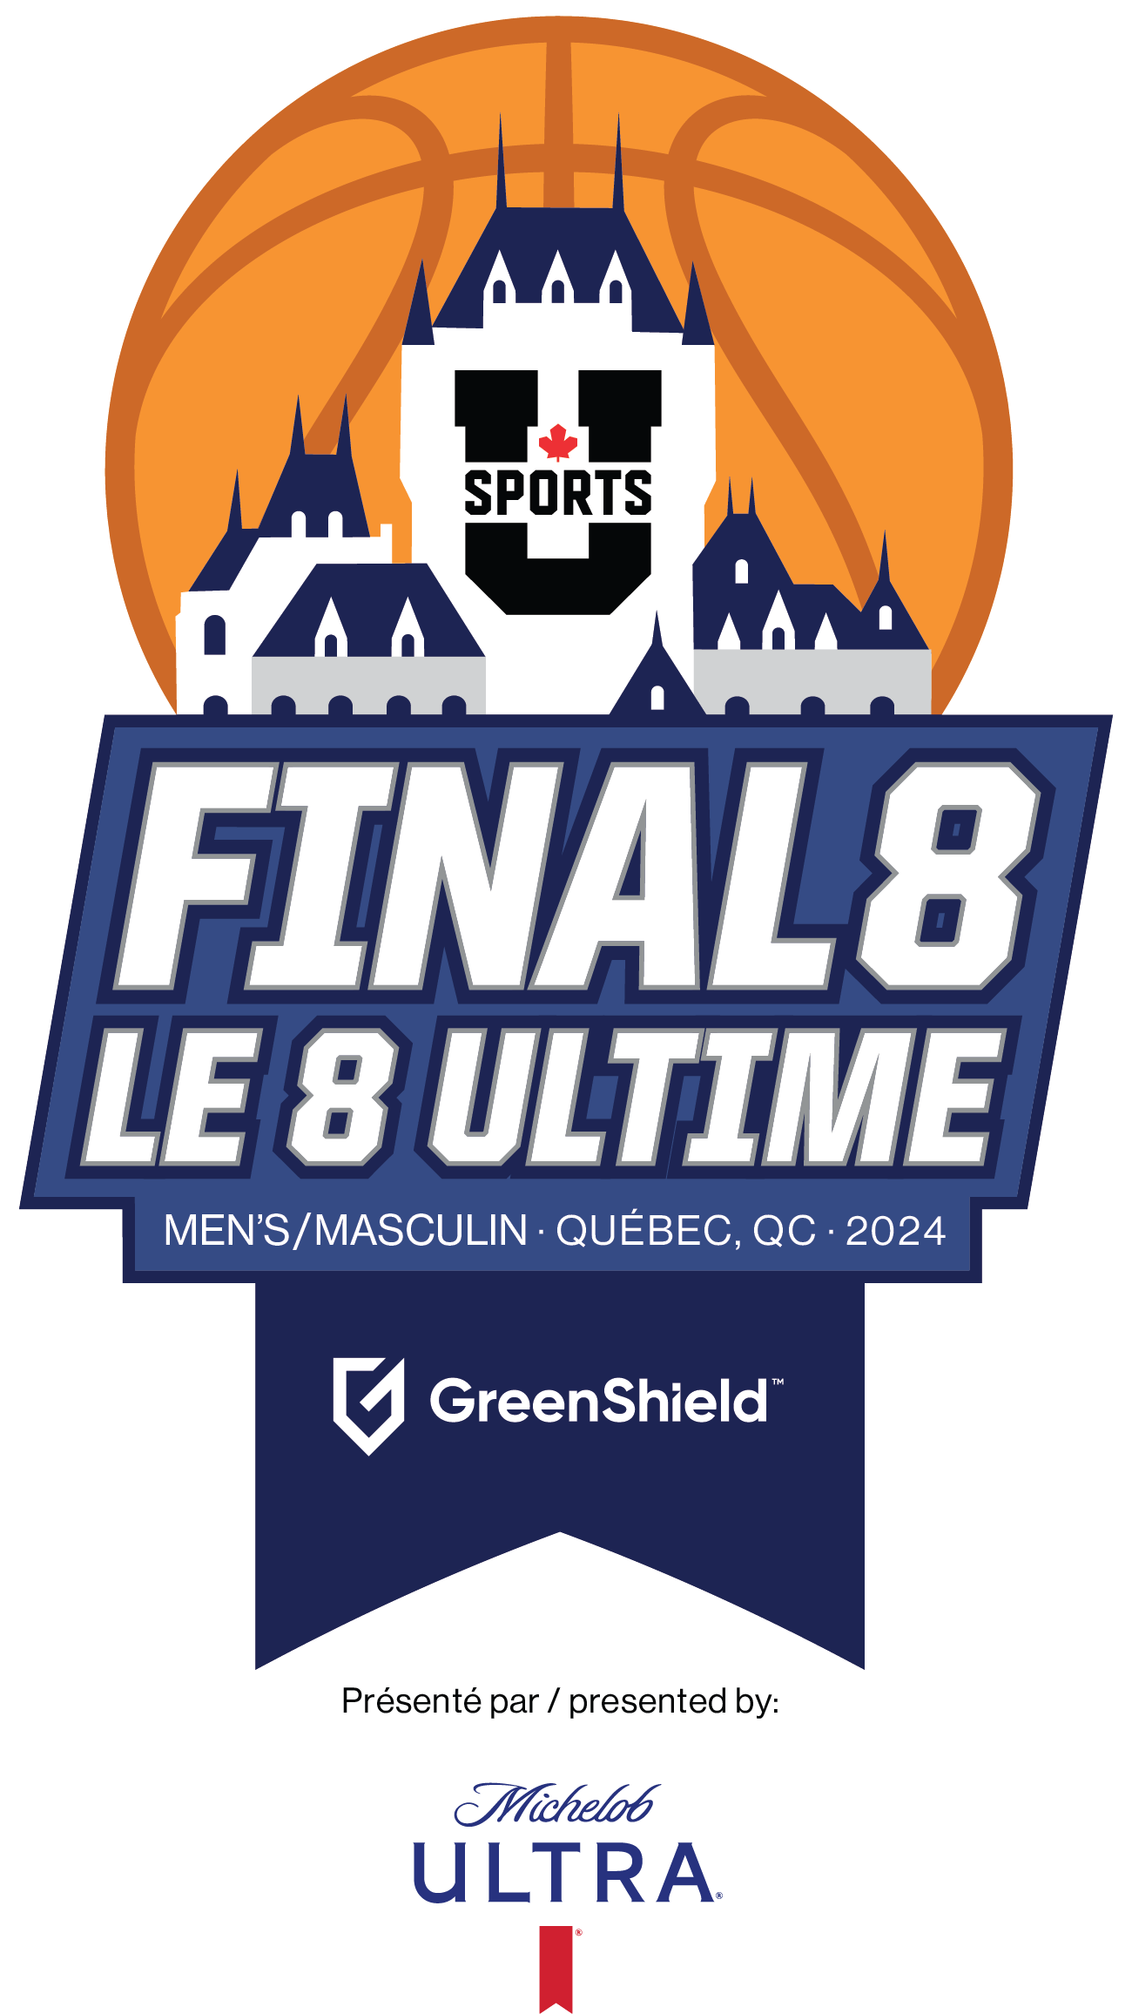
SECTION 1:
GENERAL INFORMATION

1. ORGANIZING COMMITTEE
Address: PEPS Université Laval, local 2254
2300, Rue de la Terrasse
Québec (Québec) G1V 0A6
Fax: 418-656-5749
Web page : https://rougeetor.ulaval.ca/8ultime/

FUNCTION | NAME | PHONE | EMAIL
Committee President | Charles Fortier | 418-264-4416 | cfortier@planica.ca
Rouge et Or Assistant Director | Jean-Noël Corriveau | 418-656-2456 | jean-noel.corriveau@sas.ulaval.ca
Event coordinator / Volunteers | Andréa Labonté | 418-656-2131 #409241 | andrea.labonte@sas.ulaval.ca
Housing, Banquet & Match protocol | Marie-Claude Fréchette | 418-656-2081 | marie-claude.frechette@sas.ulaval.ca
Infrastructure | Julien Blais-Durocher | 418-656-2131 #415132 | julien.blais-durocher@sas.ulaval.ca
Team services | Benjamin Corriveau | 514-887-2430 | championnat.usports@sas.ulaval.ca
Medical Services | Christine Foy | 418-802-6911 | christine.foy@sas.ulaval.ca
Sponsors & Partnership Coordinator | Olivier Turcotte | 418-656-2131 #405440 | olivier.turcotte@sas.ulaval.ca
Communications / Media | Frédéric Bherer | 418-656-2131 #405292 | Frederic.bherer@sas.ulaval.ca
Tickets | Renée D’Amboise | 418-656-3668 | billetterie@sas.ulaval.ca
DTI | Guillaume Brassard | 418-656-2131 #406025 | guillaume.brassard@sas.ulaval.ca
Directeur des sports, U SPORTS | Mark Alfano | 905-517-7887 | malfano@usports.ca
Budget | Jacques Plante | 418-563-7889 | jacplante@videotron.ca

2. EVENT CALENDAR
*All local times

THURSDAY MARCH 7, 2024
6:15pm | U SPORTS Canadian All-Star ceremony
8:45pm | U SPORTS Technical meeting

3. COMPETITION CALENDAR
** NOTE: All games will take place at Amphithéâtre-gymnase Desjardins – Université Laval

FRIDAY MARCH 8, 2024
1 :00 PM | Quarter-final #1
3 :00 PM | Quarter-final #2
6 :00 PM | Quarter-final #3 (Rouge et Or Game)
8 :00 PM | Quarter-final #4
SATURDAY MARCH 9, 2024
1 :00 PM | Semi-final #1 (Losers of games #1 & #2)
3 :00 PM | Semi-final #2 (Losers of games #3 & #4)
6 :00 PM | Semi-final #1 (Winners of games #1 & #2)
8 :00 PM | Semi-final #2 (Winners of games #3 & #4)
SUNDAY MARCH 10, 2024
12 :00 PM | 5th position’s game
2 :00 PM | Final - Bronze Medal
6 :00 PM | Final - Gold Medal

4. PRACTICE SCHEDULE
Practice times will be determined on team ranking. Once the ranking has been established, our person in charge will communicate with the participating teams at the latest March 4, in the order of the ranking, to choose the preferred practice times.

Please be prepared to respond quickly. You can begin this process by sending Team Services your first 3 practice time choices (the schedule will always be filled based on ranking).

Team Services will plan Saturday and Sunday practice times based on advancing teams and rankings.

Teams arriving before March 7th will need to contact team services to schedule practice sessions based on availability.
There is the possibility of additional practice hours at another gym on Saturdays and Sundays. Interested teams should contact Team Services.

Team Services : championnat.usports@sas.ulaval.ca

THURSDAY MARCH 7 (50 min)
8:45 to 9:35am | Practice 1 | Amphithéâtre-gymnase Desjardins UL | Team game 1pm
9:40 to 10:30am | Practice 2 | Amphithéâtre-gymnase Desjardins UL | Team game 1pm
10:35 to 11:25am | Practice 3 | Amphithéâtre-gymnase Desjardins UL | Team game 3pm
11:30am to 12:20pm | Practice 4 | Amphithéâtre-gymnase Desjardins UL | Team game 3pm
12:25 à 1:15pm | Practice 5 | Amphithéâtre-gymnase Desjardins UL | Team game 6pm
1:20 to 2:10pm | Practice 6 | Amphithéâtre-gymnase Desjardins UL | Team game 6pm
2:15 to 3:05pm | Practice 7 | Amphithéâtre-gymnase Desjardins UL | Team game 8pm
3:10 to 4:00pm | Practice 8 | Amphithéâtre-gymnase Desjardins UL | Team game 8pm
FRIDAY MARCH 8 (30 min)
7:20 to 7:50am | Practice 1 | Amphithéâtre-gymnase Desjardins UL | Team game 1pm
7h55 to 8:25am | Practice 2 | Amphithéâtre-gymnase Desjardins UL | Team game 1pm
8:30 to 9:00am | Practice 3 | Amphithéâtre-gymnase Desjardins UL | Team game 3pm
9:05 to 9:35am | Practice 4 | Amphithéâtre-gymnase Desjardins UL | Team game 3pm
9:40 to 10h10am | Practice 5 | Amphithéâtre-gymnase Desjardins UL | Team game 6pm
10h:15 to 10:45am | Practice 6 | Amphithéâtre-gymnase Desjardins UL | Team game 6pm
10:50 to 11:20am | Practice 7 | Amphithéâtre-gymnase Desjardins UL | Team game 8pm
11:25 to 11:55am | Practice 8 | Amphithéâtre-gymnase Desjardins UL | Team game 8pm

SECTION 2
INFORMATION FOR
QUALIFIED TEAMS

1. OTHER EVENTS

U SPORTS ALL-CANADIAN AWARDS CEREMONY
Date: | Thursday March 7, 2024
Place: | Ballroom – Hotel Delta
Dress code: | Formal/Business
Schedule | 6:15pm
Please note that the Major Awards and Canadian Stars Ceremony is a sit-down banquet-style meal. All attendees must reserve their tickets before March 3rd at 10 a.m. (EST) to gain access to the banquet and ceremony.

Participating Teams:

The participating teams in the 2024 U SPORTS Men's Basketball Championship will have access to the first 21 tickets at $90 each. Any additional tickets beyond the initial 21 will be priced at $125 each.
All reservations must be received by Sunday, March 3rd, 2024, at 10 a.m. Eastern Time.
CLICK HERE TO BOOK YOUR BANQUET TICKETS

U SPORTS All-Canadian nominees / major awards finalists:
All-Canadian nominees and major awards finalists who are not participating in the Championship will have 1 complimentary ticket.
All reservations must be received before: Sunday March 3rd, 2024, at 10am Eastern Time.
CLICK HERE TO BOOK YOUR BANQUET TICKETS

Coaches and Directors from non-participating teams:
Tickets are available for Coaches and Athletic Directors of the non-participating teams at 90$ each.
All reservations must be received before: Sunday March 3rd, 2024, at 10am Eastern Time.
CLICK HERE TO BOOK YOUR BANQUET TICKETS

2. MEETINGS

COACHES TECHNICAL MEETING
Date: | Thursday March 7th, 2024
Time: | 8:45pm (After The All-Canadian Awards Ceremony)
Place: | Buade room – Hotel Delta
Guests: | Coaches, Officials, U SPORTS Delegates, Organizing Committee Protocol Manager

3. INFORMATION

ACCREDITATIONS
The following individuals who wish to obtain accreditation must complete the form by clicking on the link below.

CLICK HERE TO APPLY FOR ACCREDITATION
- U SPORTS coaches
- All Canadian (non active players)
- U SPORTS dignitaries
- Sponsors
- Press
- Photographer - Camera

4. CHAMPIONSHIP HOTEL

U SPORTS POLICY 20.40.3.4.1:
All participating teams and team personnel attending a U SPORTS Championship requiring accommodation must stay at the U SPORTS Championship designated host hotel

OFFICIAL TEAMS HOTEL
Hotel: Hôtel Delta par Marriott Québec
Address: 690, boulevard René-Lévesque Est,
Québec, Qc, G1R 5A8
Web site: www.marriott.com/en-us/hotels/yqbdr-delta-hotels-quebec
Contact: Julie Labbé (julie.labbe@deltahotels.com)
Reservation: 418-647-6580
Distance from ULaval: 5.9 km

Standard room from: | Junior suite from: | Meeting room
179$ +tx * | 379$ tx * | 375$ tx / day

Sixteen (16) rooms with two (2) beds and one (1) room with one (1) bed, along with a meeting room, have been reserved for the players and coaches of each participating team.

All additional costs for rooms, meals, and extra charges will be billed to the teams. To secure a reservation, guests are required to provide a credit card as a guarantee. If a team spends over $10,000 on food and beverage, their meeting room rental fees will decrease to $225 per day.

Participating teams must contact the official hotel as soon as possible. The confirmed room list must be submitted by 6 p.m. (EST) on March 3rd.

5. TRANSPORTATION

SHUTTLE

A shuttle service will be offered from the hotel to the airport for U SPORTS representatives, other university coaches and the all-Canadian team nominees.
The shuttle service will provide round-trip transportation for the following:
Airport to Delta Hotel
Delta Hotel to the competition venue
Reservations must be requested 24 hours before the intended travel by emailing the following address:

championnat.usports@sas.ulaval.ca

TEAMS TRANSPORTATION

Teams are responsible for all their travel.
Enterprise will be the official vehicle rental service provider for the championship. Teams are responsible for reserving and paying for their own transportation.
Website : enterpriseholding.com
Contact : Rose-Marie Auger
Email : rosemarie.auger@ehi.com
Phone : 418-522-3598
Bus parking will be available for free on the campus. The team services will provide you with the information upon your arrival.

6. TEAMS REGISTATION AND ACCREDITATION
TEAMS ACCREDITATIONS

All teams must send their travel plans to :championnat.usports@sas.ulaval.ca. All teams will be met at the hotel by a representative of the organizing committee.
Every team will be receiving 21 accreditations. For all additional request regarding accreditations including those for recruiters and sports directors, please send a written request to championnat.usports@sas.ulaval.ca before Sunday March 3, 2024, 12 PM Eastern Time.
Accreditations will be given to university coaches, participating athletes and nominees of the U SPORTS All-Canadian Team Award Ceremony, sports directors and to university recruiters.
If those accreditations are used, a confirmation must be received before March 3, 2024, 12 PM Eastern Time.
Please send your confirmation to championnat.usports@sas.ulaval.ca

7. TEAM SERVICES

The team services will communicate with all qualified teams before the start of the championship.

SALLE DE RÉUNION D’ÉQUIPE

(1) meeting and meal rooms, have been reserved for the players and coaches of each participating team.

All additional costs for rooms, meals, and extra charges will be billed to the teams. To secure a reservation, guests are required to provide a credit card as a guarantee. If a team spends over $10,000 on food and beverage, their meeting room rental fees will decrease to $225 per day.

8. SPONSORS

CHAMPIONSHIP LOCAL SPONSORS

Greenshield, Labatt, TELUS, Café Smith, Fédération des producteurs d’œufs du Québec,

U SPORTS CHAMPIONSHIP SPONSORS

Nike Team, Baron Rings, Sherrard Kuzz, Sport Canada, CBC Sports, TVA Sports, Fox 40, Vereburn Medical, Wilson

9. TECHNICAL INFORMATION
COMPETITION SITE

Amphithéâtre gymnase - Université Laval
Dimensions: | 125 x 153 feet
Surface: | Hardwood
Capacity: | 3 000 seats
Dressing Rooms: | Accessible during games for the playing teams
Video display: | 14 x 23 feet LED screen

ÉQUIPMENT

The official match ball for the championship will be Wilson B0511X.

LAUNDRY

Laundry service for game uniforms will be available at Université Laval.
Please note this service is not intended for personal use.
Towel service will be provided.
Someone from the organizing committee will contact all qualified teams

TEAM ROOMS
The PEPS facility at L’Université Laval features six locker rooms designated for visiting teams, each equipped with a toilet room, showers, and a whiteboard. Locker room assignments are determined by a rotating schedule based on match times. Teams gain access to the locker rooms 90 minutes before the start of their match and are required to vacate them within 30 minutes after the match concludes. The team service will be responsible for managing the distribution of locker rooms and keys.

10. MEDICAL SERVICES
Medical services

Emergency Action Plan

11. HOSPITALITY

VIP Zone – PEPS de l’Université Laval

A VIP Zone will be offered on the championship site during the matches. Access to this space will require VIP accreditation. This VIP accreditation must only be used by those identified by U SPORTS regulations. This VIP lounge will be located in the Desjardins-Université Laval Amphithéâtre-gymnase, behind section 210.
SECTION 3
FAN ZONE

- HOUSING FOR FRIENDS & FAMILY

Hotel: Hôtel Delta par Marriott Québec
Address: 690, boulevard René-Lévesque Est,
Québec, Qc, G1R 5A8
Web site: www.marriott.com/en-us/hotels/yqbdr-delta-hotels-quebec
Reservation: 418-647-1717
Distance from Université: 5.9 km
Prices:
Standard room from : | Junior suite from :
179$ tx * | 379$ tx *

Book your group rate for 2024 U Sports men’s basketball championship, presented by Greenshield

You have until February 2, 2024 to reserve your nights.

- TICKET INFORMATION
 |  | Children | Adult | Baby | Court Side
 |  | (3 à 17 yrs) | (18 yrs & more) | (2 yrs & under )
***Service charge extra *** |  |  |  |  |  | Achat en ligne
Friday March 8 | Session #1 (1pm & 3pm) | 23 $ | 35 $ | Free | - | https://www.reservatech.net/events/13383
 | Session #2 (6pm & 8pm) | 23 $ | 35 $ | Free | -
Saturday March 9 | Session #3 (1pm & 3pm) | 23 $ | 35 $ | Free | -
 | Session #4 (6pm & 8pm) | 23 $ | 35 $ | Free | -
Sunday march 10 | Session #5 (0pm & 2pm) | 23 $ | 35 $ | Free | -
 | Session #6 (6pm ) | 23 $ | 35 $ | Free | - | https://www.reservatech.net/events/13582
Sunday package (3 game) |  | 35 $ | 48 $ | Free | - | https://www.reservatech.net/packages/2214
3 days package |  | 95 $ | 145 $ | Free | 290 $ | https://www.reservatech.net/packages/2211

To purchase tickets in the teams section, please contact the ticket office
Ticketing : 9am to 12pm et 1:30pm to 6:30pm from Monday to Friday

- CITY GUIDE

Québec City is full of activities to do:

- Musée de la civilisation - https://www.mcq.org/fr/
- Défi-Évasion - https://defi-evasion.com/ (à l’extérieur https://defi-evasion.com/parcours/ )
- Citadelle de Québec - https://www.lacitadelle.qc.ca/fr/
- Terrasse Dufferin (vue sur Château Frontenac) - https://www.quebec-cite.com/fr/quoi-faire-quebec/terrasse-dufferin
- Match des Remparts (Hockey) - https://remparts.ca/
- Musée des beaux arts - https://www.mnbaq.org/
- Port de Québec - https://www.portquebec.ca/
- Musée des plaines - https://www.ccbn-nbc.gc.ca/fr/musee-des-plaines-abraham/renseignements/horaire-tarification/
- Observatoire de la capitale - https://observatoire-capitale.com/
- Marina St-Roch – https://www.facebook.com/reverlamarina/
- Château Frontenac - https://www.fairmont.com/

- RESTAURANTS & BARS

Here is a website of all the restaurants in Quebec City:

https://www.restoquebec.ca/

