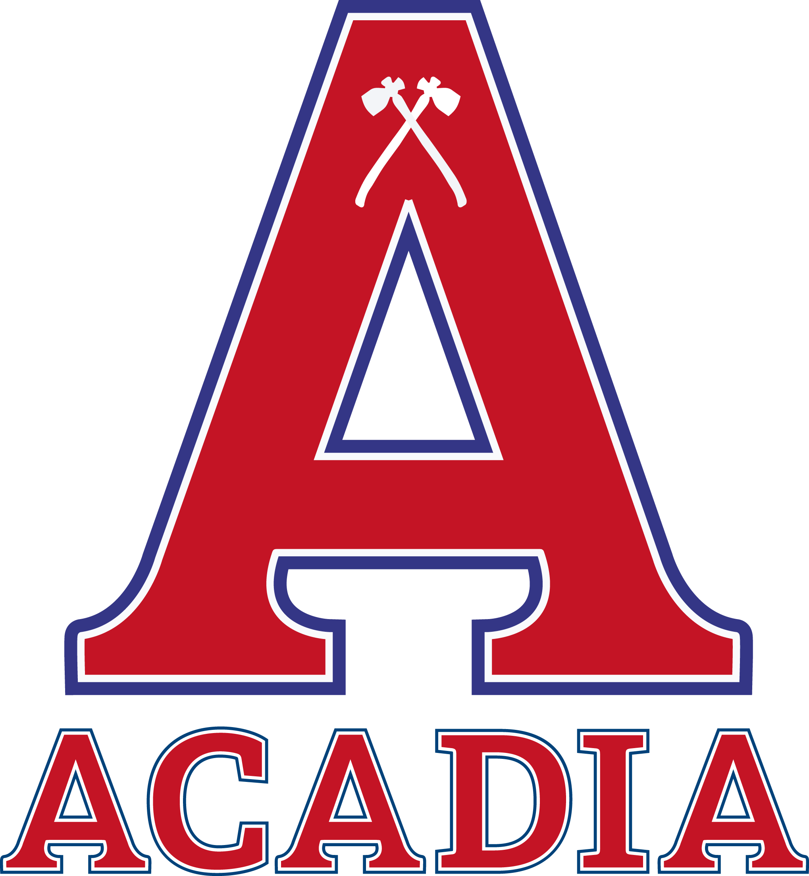
2020 U Sports University Cup
MEDIA ACCREDITATION FORM
March 11 to 15, 2020
Scotiabank Centre, Halifax, NS

Name_______________________________________________________
Media Outlet_________________________________________________
Outlet Twitter Handle__________________________________________
Name of Director/Editor________________________________________
Mailing Address_______________________________________________
Phone (home)______________ Cell______________ Work____________
Email_______________________________________________________
Professional Twitter Handle_____________________________________

- Please check one of the following:
___ I will be covering the University Cup only if ___________ is playing.
___ I will be covering the University Cup regardless of the teams playing
- The capacity in which I will be covering the University Cup Championship:
___ Newspaper Reporter ____ Television Reporter ____ Radio Reporter
___ Still Photographer ____ Camera Person ____ Internet
___ Other Print Reporter ____ Sports Information Officer
___ Web Broadcast ____ Other (please specify)___________________
- I intend to cover the following University Cup events as media:
___ Meet the Coaches Media Conference, Wed, March 11, 2020, 11:15am at the Scotiabank Centre, Sport Hall of Fame
___ U SPORTS All-Canadian Gala Awards Dinner, Wed, March 11, 2020. 6:30pm at Marriott Halifax Harbourfront Hotel
___ University Cup Tournament Play, March 12 to 15, 2020
- Media Seating
___ I require a seat in the Press Box for all games
___ I do not require a seat in the Press Box for all games

- Hotel Information:
Halifax Marriott Harbourfront Hotel;
1919 Upper Water Street, Halifax, NS, B3J 3J5
1-855-516-1093, 902-421-1700
Hotel Halifax
1990 Barrington Street, Halifax, NS, B3J 1P2
902-425-6700 or 1-888-236-2427
Notes:
**Application does not guarantee accreditation; applicants will be notified about the status of application via email.
**Media accreditation applications are to be completed and returned no later than Monday March 9, 2020, by email to jjacobson@eastlink.ca.
**A complete schedule of events (practices, games, etc) will be sent to you with your confirmation of your accreditation.
**Accreditation pickup is located in the Media Centre, Scotiabank Centre,
Wednesday March 11, 2020, 10:00am to 3:00pm
Thursday March 11 to Sunday March 15, 2020, 9am to 3pm daily

CAMERA AND VIDEO OPERATORS PLEASE NOTE
No photographers/ENG operators/reporters will be allowed to shoot still or moving photos during the event without the proper pass. The undersigned agrees that all photographs taken/articles written during the festivities are exclusively for the editorial usage for the publications listed above.

The undersigned further agrees that they will not be permitted to use strobe lighting during the events.

ENG camera operators will be permitted to shoot live game footage during the event, and will be permitted to shoot pre and post game media conferences and other events associated with the games.

The undersigned acknowledges that they have read the above terms and conditions for which the pass is issued and agrees to abide by them. Failure to do so may result in legal action and/or forfeiture of privileges granted by U SPORTS and the Host Committee by both the individual and the organization that they represent.

X
_______________________________________________
Signature of Applicant

X
_______________________________________________________________
Signature of Editor/Sports Director

